Guided Capstone Report: Big Mountain Resort Summary Report

Big Mountain resort is trying to find an adequate ticket value to increase revenue to at least cover the costs of the $1,540,000 newly implemented ski lift before the end of the year.

Big Mountain Resort has special access to unique views of Glacier National Park and Flathead National Forest. Furthermore, they have access to 105 trails; however, their price is calculated by adding a premium to of the average price of resorts. Nonetheless their price does not reflect what they have to offer. By looking at adult weekday and weekend prices The current position of Big Mountain resort is at $81.00. The modeled price that seems to be supported by the marketplace, is $95.39 with a mean absolute error of $10.37. Big Mountain Resort is on the higher end when it comes to facilities. However, this is justifiable because Big Mountain Resort had more skiable terrain (Figure 1), more snow coverage, more market shares than most other resorts.

Moreover, when modeling the features that came up to be as important were the vertical drop, amount of snow making, total number of chairs, fast quads availability, the number of runs, the longest run in miles, trams, and skiable terrain. From modeling all these unique values separately only changing the number of runs, increasing the vertical drop, and adding a chair lift influenced the pricing of Big Mountain Resort’s ticket.

For example, closing one run will not change the price. Nonetheless closing two or more runs will reduce support for increasing ticket prices (Figure 2). Furthermore, increasing the drop to 150 feet, and installing one additional chair lift allows for an increase in ticket price by $1.46, which in one season can amount to be to $2,561,594. Thus, the best suggestion would be to suggest either to increase the price of Big Mountain Resorts’ tickets and to close one run, or to increase the ticket price and add one run, increase the drop to 150 feet, and install one additional chair lift to increase the ticket price even further by $1.46. The following suggestions can successfully cover the costs of the newly implemented ski lift since the new ski lift will cost around $1,540,000 however installing the new chair lift, adding one run, and increasing the drop to 150 feet can amount to be $2,561,594 in one season which is much greater than $1,540,000. Enough data was collected (as shown in Figure 3) and no further data will need to be collected. There are multiple opportunities to increase the ticket price for Big Mountain Resort.

Figure 1: Big Mountain Resort in Comparison to Other Ski Resorts

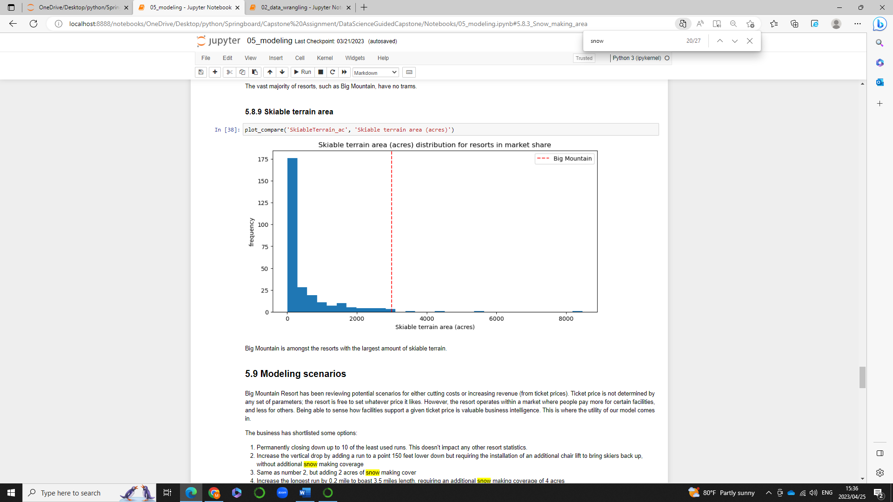

Figure 1 shows Big Mountain Resort having more skiable terrain than a majority of the other resorts as indicated by the red dashed line.

Figure 2.

Figure 2 shows that closing 1 run does not make a difference, however closing two or more runs will affect the price of Big Mountain Resort as the graph shows a steep slope downwards.

Figure 3.

Figure 3 shows the cross validation scores and levels off at a sample size of 40. No further data will need to be collected.